Detail Design Document(JSP)

V 1.0

Eric CHEN



Sep. 25, 2001
Document Control

Change Record

Date | Author | Version | Change Reference
09/25/2001 | Eric | 1.0

Reviewers

Date | Name | Position
9/24/2001 | Erin | PM
9/24/2001 | Eric | Tech Lead
9/24/2001 | Hurt Xiang, Shui Wang, Zhiguo Zheng | DV
9/24/2001 | John
9/24/2001 | Jack | Architecture
9/24/2001 | Cedric | QA

Approved By

Name | Position | Signature | Date

Table of Contents
Table of Contents 3
Logical View 8
com 8
dc 8
eschool 8
answeritem 13
cortrol 13
AnswerItemHome 13
AnswerItemSL 13
AnswerItemSLBean 13
dao 14
AnswerItemDAO 14
ejb 14
AnswerItemEB 14
AnswerItemEBBean 15
AnswerItemEBBeanPK 16
AnswerItemEBHome 16
model 17
AnswerItemModel 17
architecture 20
EJBController 20
EJBControllerBean 20
EJBControllerHome 21
EJBControllerWebImpl 21
MainException 22
MainServlet 23
ModelManager 24
ModelUpdateListener 25
ModelUpdateManager 25
ModelUpdateNotifier 25
Parameter 26
RequestProcessor 27
Screen 28
ScreenFlowData 28
ScreenFlowManager 29
ScreenFlowXmlDAO 31
StateHandler 34
StateMachine 35
URLMapping 36
event 37
MainEvent 37
handlers 38
FlowHandler 38
RequestHandler 38
util 39
EJBUtil 39
JNDINames 40
JSPUtil 41
WebKeys 42
class 44
cortrol 44
ClassSL 44
ClassSLBean 44
ClassSLHome 45
dao 45
ClassDAO 45
ejb 46
ClassEB 46
ClassEBBean 46
ClassEBBeanPK 47
ClassEBHome 47
model 48
ClassModel 48
content 50
controll 50
ContentManageSL 51
ContentManageSLBean 52
ContentManageSLHome 52
dao 53
ContentDAO 53
ContentManageDAO 53
ejb 54
ContentEB 54
ContentEBBean 55
ContentEBHome 56
exceptions 56
model 57
ContentModel 57
util 57
course 57
cortrol 58
CourseSL 58
CourseSLBean 58
CourseSLHome 59
dao 59
CourseDAO 59
ejb 59
CourseEB 59
CourseEBBean 60
CourseEBBeanPK 60
CourseEBHome 61
model 61
CourseModel 61
coursestudent 64
cortrol 64
CourseStudentSL 64
CourseStudentSLBean 65
CourseStudentSLHome 65
dao 66
CourseStudentDAO 66
ejb 66
CourseStudentEB 66
CourseStudentEBBean 66
CourseStudentEBBeanPK 68
CourseStudentEBHome 68
model 68
CourseStudentModel 68
examinationscore 71
cortrol 71
ExaminationscoreSL 71
ExaminationscoreSLBean 71
ExaminationscoreSLHome 72
dao 72
ExaminationScoreDAO 72
ejb 73
ExaminationscoreEB 73
ExaminationscoreEBBean 73
ExaminationscoreEBBeanPK 74
ExaminationscoreEBHome 75
model 75
ExaminationScoreModel 75
homework 78
controll 78
HomeworkSL 78
HomeworkSLBean 79
HomeworkSLHome 80
dao 80
HomeworkContentManageDAO 80
HomeworkDAO 80
HomeworkManageDAO 81
ejb 81
HomeworkEB 81
HomeworkEBBean 82
HomeworkEBHome 83
HomeworkEBPK 84
list 84
HomeworkTag 84
ListTag 85
model 87
HomeworkModel 87
ListChunk 88
web 89
HomeworkWebImpl 89
homeworkContent 89
controll 89
HomeworkContentSL 89
HomeworkContentSLBean 90
HomeworkContentSLHome 91
dao 92
HomeworkContentDAO 92
ejb 92
HomeworkContentEB 92
HomeworkContentEBBean 92
HomeworkContentEBHome 93
HomeworkContentEBPK 94
model 94
HomeworkContentModel 94
project 95
controll 96
ProjectManageSL 96
ProjectManageSLBean 97
ProjectManageSLHome 98
dao 98
ProjectDAO 98
ProjectManageDAO 99
ejb 99
ProjectEB 99
ProjectEBBean 99
ProjectEBHome 101
exceptions 101
ProjectDAOException 101
model 101
ProjectModel 101
util 103
projectcontent 103
ProjectContModel 103
schoolresource 104
cortrol 104
SchoolResourceSL 104
SchoolResourceSLBean 104
SchoolResourceSLHome 105
dao 105
SchoolResourceDAO 105
ejb 105
SchoolResourceEB 105
SchoolResourceEBBean 106
SchoolResourceEBBeanPK 107
SchoolResourceEBHome 107
model 108
SchoolResourceModel 108
scorestatistic 111
cortrol 111
ScorestatisticsSL 111
ScorestatisticsSLBean 111
ScorestatisticsSLHome 112
dao 112
ScorestatisticDAO 112
ejb 113
ScorestatisticsEB 113
ScorestatisticsEBBean 113
ScorestatisticsEBBeanPK 114
ScorestatisticsEBHome 115
model 115
ScoreStatisticsModel 115
subject 118
cortrol 119
SubjectSL 119
SubjectSLBean 119
SubjectSLHome 119
dao 120
SubjectDAO 120
ejb 120
SubjectEB 120
SubjectEBBean 120
SubjectEBBeanPK 121
SubjectEBHome 122
model 122
SubjectModel 122
testresultsitem 124
cortrol 125
TestResultsItemSL 125
TestResultsItemSLBean 125
TestResultsItemSLHome 125
dao 126
TestResultsItemDAO 126
ejb 126
TestResultsItemEB 126
TestResultsItemEBBean 127
TestResultsItemEBBeanPK 128
TestResultsItemEBHome 128
model 128
TestResultsItemModel 128
users 132
control 132
UsersSL 132
UsersSLBean 132
UsersSLHome 133
dao 133
UsersDAO 133
ejb 134
UsersEB 134
UsersEBBean 134
UsersEBBeanPK 135
UsersEBHome 136
model 136
UsersModel 136
util 140
DatabaseName 140
GeneralDAO 141

Logical View

Class Diagram - Main

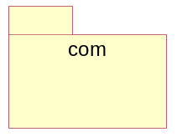

com

dc

eschool

Class Diagram - Homework

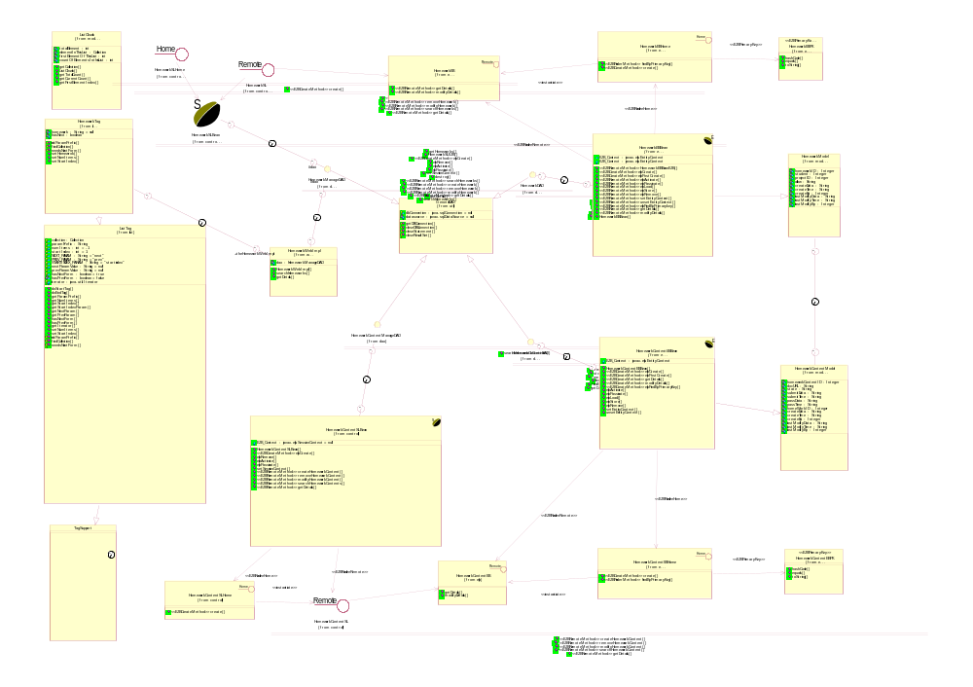

Class Diagram - project_content

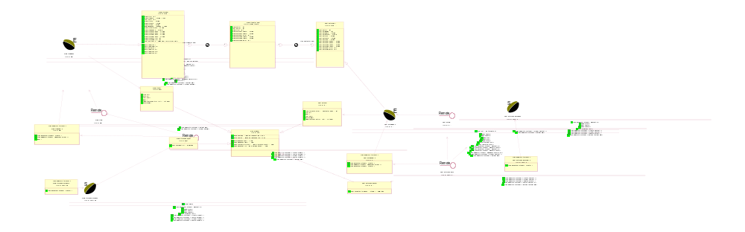

Class Diagram - Architecture

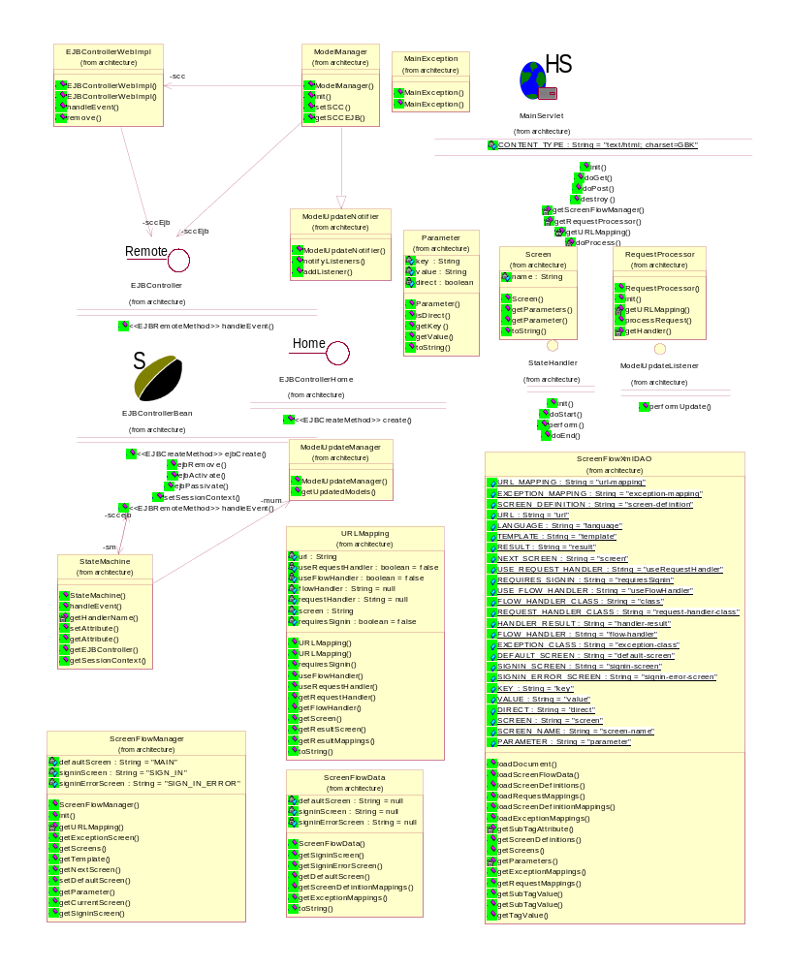

Class Diagram - Examination

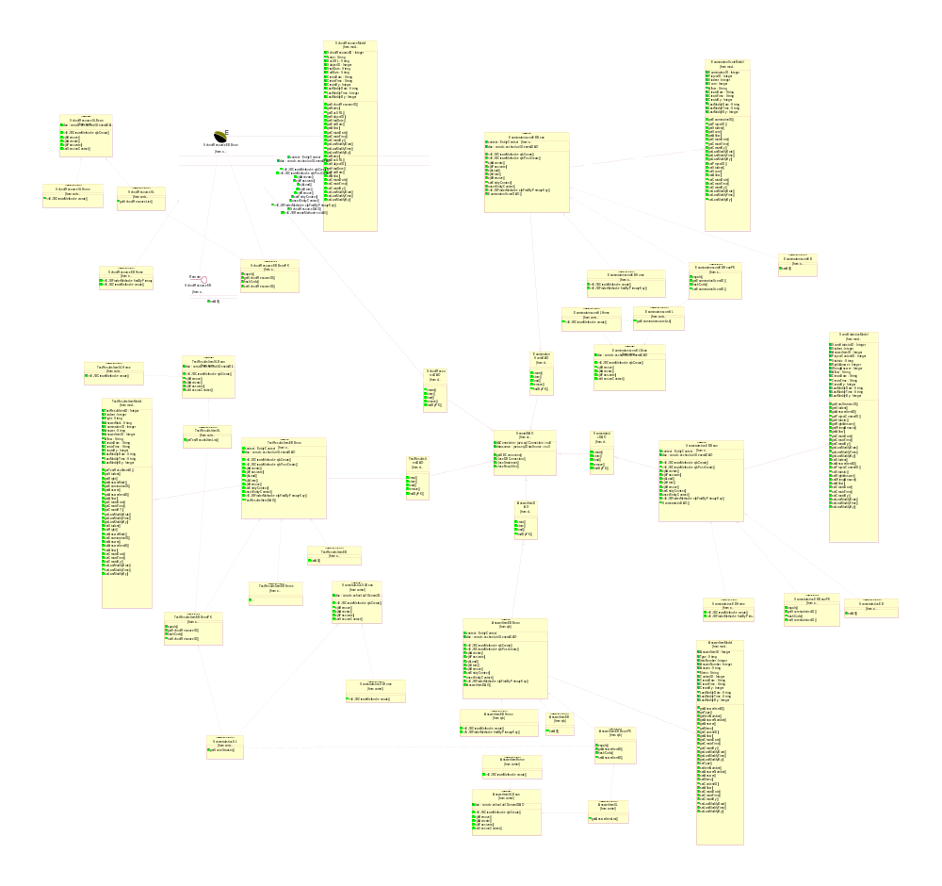

Class Diagram - classuser

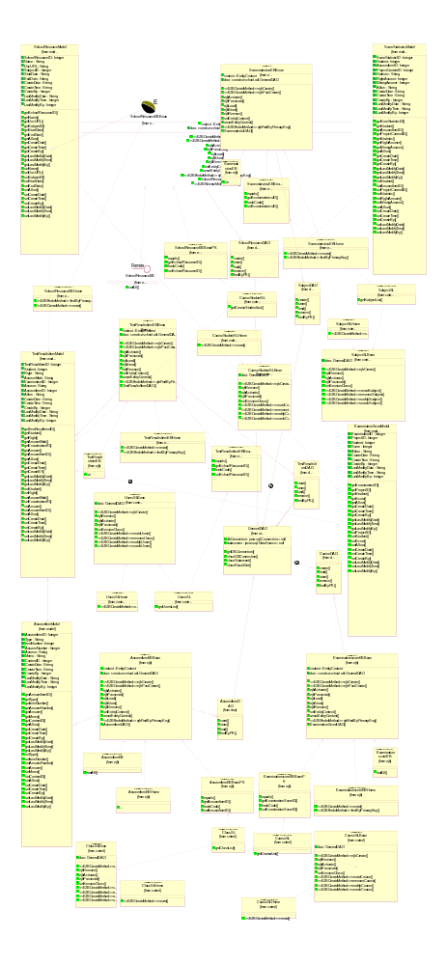

answeritem

cortrol

AnswerItemHome

Public Operations:

create () : AnswerItemSL

AnswerItemSL

Public Operations:

getAnswerItemList ( AnswerItemPK : AnswerItemPK) :

detail list of the answeritem information for the specified project

AnswerItemPK

AnswerItemSLBean

Private Attributes:

dao : com.dc.eshool.util.GeneralDAO

extend of GeneralDAO

Public Operations:

ejbCreate () : void

ejbRemove () : void

ejbActivate () : void

ejbPassivate () : void

setSessionContext ( sc : SessionContext) : void

sc

dao

AnswerItemDAO

Database access object of AnswerItemEBBean.

Derived from GeneralDAO

Public Operations:

creat () : com.dc.eschool.answeritem.ejb.AnswerItemEBBeanPK

store () : void

load () : void

findByPK () : com.dc.eschool.answeritem.ejb.AnswerItemEBBeanPK

ejb

AnswerItemEB

This interface provides methods to view and modify answeritem information for a particular project.

Public Operations:

setAll ( answeritem : com.dc.eschool.dao.AnswerItemModel) : void

updates the answeritem information for the specified project

answeritem

AnswerItemEBBean

EJB of AnswerItem

Derived from AnswerItemDAO, AnswerItemModel

Public Attributes:

context : EntityContext

Private Attributes:

dao : com.dc.eschool.util.GeneralDAO

extend GeneralDAO

Public Operations:

ejbCreate () : AnswerItemEBBeanPK

ejbPostCreate () : void

ejbActivate () : void

ejbPassivate () : void

ejbLoad () : void

ejbStore () : void

ejbRemove () : void

setEntityContext ( ctx : EntityContext) : void

ctx

unsetEntityContext () : void

ejbFindByPrimaryKey ( primaryKey : AnswerItemEBBeanPK) : AnswerItemEBBeanPK

primaryKey

AnswerItemDAO () : void

extend AnswerItemDAO

AnswerItemEBBeanPK

Public Operations:

equals ( obj : Object) : void

obj

getAnswerItemID () : Integer

hashCode () : int

setAnswerItemID ( newAnswerItemID : int) : int

newAnswerItemID

AnswerItemEBHome

HomeInterface of AnswerItem Entity Bean.

Public Operations:

create () : AnswerItemEB

findByPrimaryKey ( primaryKey : AnswerItemEBBeanPK) : AnswerItemEB

primaryKey

model

AnswerItemModel

Entity Bean to describe AnswerItemModel

Private Attributes:

AnswerItemID : Integer

Type : String

ItemNumber : Integer

AnswerNumber : Integer

Answer : String

Memo : String

ContentID : Integer

CreateDate : String

CreateTime : String

CreateBy : Integer

LastModifyDate : String

LastModifyTime : String

LastModifyBy : Integer

Public Operations:

getAnswerItemID () : Integer

get of answeritemid

getType () : String

get of type

getItemNumber () : Integer

get of itemnumber

getAnswerNumber () : String

get of answernumber

getAnswer () : String

get of answer

getMemo () : String

get of memo

getContentID () : Integer

get of contentid

getAllow () : String

get of allow

getCreateDate () : String

get of createdate

getCreateTime () : String

get of createtime

getCreateBy () : Integer

get of createby

getLastModifyDate () : String

get of lastmodifydate

getLastModifyTime () : String

get of lastmodifytime

getLastModifyBy () : Integer

get of lastmodifyby

setType ( Type : String) : void

update of type
Type

setItemNumber ( ItemNumber : Integer) : void

update of itemnumber

ItemNumber

setAnswerNumber ( AnswerNumber : String) : void

update of answernumber

AnswerNumber

setAnswer ( Answer : String) : void

update of answer

Answer

setMemo ( Memo : String) : void

update of memo

Memo

setContentID ( ContentID : Integer) : void

update of contentid

ContentID

setAllow ( Allow : String) : void

update of allow

Allow

setCreateDate ( CreateDate : String) : void

update of createdate

CreateDate

setCreateTime ( CreateTime : String) : void

update of createtime

CreateTime

setCreateBy ( CreateBy : Integer) : void

update of createby
CreateBy

setLastModifyDate ( LastModifyDate : String) : void

update of lastmodifydate

LastModifyDate

setLastModifyTime ( LastModifyTime : Integer) : void

update of lastmodifytime

LastModifyTime

setLastModifyBy ( LastModifyBy : Integer) : void

update of lastmodifyby

LastModifyBy

architecture

EJBController

This is the EJB-tier controller of the MVC.
It is implemented as a session EJB. It controls all the activities
that happen in a client session.
It also provides mechanisms to access other session EJBs.

Associations:

(Unnamed Target Role) [] : Unnamed Association (sccEjb Role) to EJBControllerWebImpl

(Unnamed Target Role) [] : Unnamed Association (sccEjb Role) to ModelManager

Public Operations:

handleEvent ( ese : testejb.event.MainEvent) : java.util.Collection

ese

EJBControllerBean

Session Bean implementation for ShoppingClientController EJB.

Associations:

sc [] : Unnamed Association (Unnamed Supplier Role) to SessionContext

sm [] : Unnamed Association (Unnamed Supplier Role) to StateMachine

(Unnamed Target Role) [] : Unnamed Association (sccejb Role) to StateMachine

Public Operations:

ejbCreate () : void

ejbRemove () : void

ejbActivate () : void

ejbPassivate () : void

setSessionContext ( sessionContext : javax.ejb.SessionContext) : void

sessionContext

handleEvent ( ese : testejb.event.MainEvent) : java.util.Collection

ese

EJBControllerHome

The Home interface for ShoppingSessionController EJB

Public Operations:

create () : testejb.EJBController

EJBControllerWebImpl

Associations:

sccEjb [] : Unnamed Association (Unnamed Supplier Role) to EJBController

session [] : Unnamed Association (Unnamed Supplier Role) to HttpSession

(Unnamed Target Role) [] : Unnamed Association (scc Role) to ModelManager

Public Operations:

EJBControllerWebImpl () :

EJBControllerWebImpl ( session : javax.servlet.http.HttpSession) :

session

handleEvent ( ese : testejb.event.MainEvent) : java.util.Collection

feeds the specified event to the state machine of the business logic.
@param ese is the current event
@return a list of models that got updated because of the
processing of this event.
@exception com.sun.j2ee.blueprints.petstore.control.EStoreEventException <description>
@exception com.sun.j2ee.blueprints.petstore.control.GeneralFailureException

ese

remove () : void

frees up all the resources associated with this controller and
destroys itself.

MainException

Public Operations:

MainException () :

MainException ( str : String) :

str

MainServlet

Private Attributes:

CONTENT_TYPE : String = "text/html; charset=GBK"

Associations:

urlMappings [] : Unnamed Association (Unnamed Supplier Role) to HashMap

Public Operations:

init () : void

Initialize global variables

doGet ( request : javax.servlet.http.HttpServletRequest, response : javax.servlet.http.HttpServletResponse) : void

Process the HTTP Get request

request

response

doPost ( request : javax.servlet.http.HttpServletRequest, response : javax.servlet.http.HttpServletResponse) : void

Process the HTTP Post request

request

response

destroy () : void

Clean up resources

Private Operations:

getScreenFlowManager () : testejb.ScreenFlowManager

getRequestProcessor () : testejb.RequestProcessor

getURLMapping ( urlPattern : String) : testejb.URLMapping

urlPattern

doProcess ( request : javax.servlet.http.HttpServletRequest) : void

request

ModelManager

This interface provides a convenient set of methods for the
web tier components to access all the model objects.
This class also insures that only one copy of the model objects
are created for web tier access by placing a reference to the
model objects in the session.

Derived from ModelUpdateNotifier

Associations:

context [] : Unnamed Association (Unnamed Supplier Role) to ServletContext

session [] : Unnamed Association (Unnamed Supplier Role) to HttpSession

sccEjb [] : Unnamed Association (Unnamed Supplier Role) to EJBController

scc [] : Unnamed Association (Unnamed Supplier Role) to EJBControllerWebImpl

Public Operations:

ModelManager () :

init ( context : javax.servlet.ServletContext, session : javax.servlet.http.HttpSession) : void

context

session

setSCC ( scc : testejb.EJBControllerWebImpl) : void

scc

getSCCEJB () : testejb.EJBController

ModelUpdateListener

Public Operations:

performUpdate () : void

ModelUpdateManager

This class uses the EStoreEvent type to deduce the list of models that need to be updated because of this event.

Associations:

(Unnamed Target Role) [] : Unnamed Association (mum Role) to StateMachine

Public Operations:

ModelUpdateManager () :

getUpdatedModels ( ese : testejb.event.MainEvent) : java.util.Collection

@return a list of names of models that could have changed due to this event.
The names chosen to refer to models is taken from JNDINames.
@see com.sun.j2ee.blueprints.petstore.util.JNDINames

ese

ModelUpdateNotifier

This class is responsible for providing methods to add objects as listeners for a particular model update event and for notifying the listeners when the event actually occurs.

Associations:

listenerMap [] : Unnamed Association (Unnamed Supplier Role) to HashMap

Public Operations:

ModelUpdateNotifier () :

notifyListeners ( updatedModelList : java.util.Collection) : void

updatedModelList

addListener ( modelType : String, listener : Object) : void

modelType

listener

Parameter

Private Attributes:

key : String

value : String

direct : boolean

Public Operations:

Parameter ( key : String, value : String, direct : boolean) :

key

value

direct

isDirect () : boolean

getKey () : String

getValue () : String

toString () : String

RequestProcessor

This is the web tier controller for the sample application.
This class is responsible for processing all requests received from the Main.jsp and generating necessary events to modify data which are sent to the ShoppingClientControllerWebImpl.

Associations:

context [] : Unnamed Association (Unnamed Supplier Role) to ServletContext

urlMappings [] : Unnamed Association (Unnamed Supplier Role) to HashMap

Public Operations:

RequestProcessor () :

Empty constructor for use by the JSP engine.

init ( context : javax.servlet.ServletContext) : void

context

processRequest ( request : javax.servlet.http.HttpServletRequest) : void

This method is the core of the RequestProcessor. It receives all requests
and generates the necessary events.

request

Private Operations:

getURLMapping ( urlPattern : String) : testejb.URLMapping

The UrlMapping object contains information that will match
a url to a mapping object that contains information about
the current screen, the RequestHandler that is needed to
process a request, and the RequestHandler that is needed
to insure that the propper screen is displayed.

urlPattern

getHandler ( selectedUrl : String) : testejb.handlers.RequestHandler

This method load the necessary RequestHandler class necessary to process a the
request for the specified URL.

selectedUrl

Screen

Private Attributes:

name : String

Associations:

parameters [] : Unnamed Association (Unnamed Supplier Role) to HashMap

Public Operations:

Screen ( name : String, parameters : java.util.HashMap) :

name

parameters

getParameters () : java.util.HashMap

getParameter ( key : String) : testejb.Parameter

key

toString () : String

ScreenFlowData

Private Attributes:

defaultScreen : String = null

signinScreen : String = null

signinErrorScreen : String = null

Associations:

exceptionMappings [] : Unnamed Association (Unnamed Supplier Role) to HashMap

screenDefinitionMappings [] : Unnamed Association (Unnamed Supplier Role) to HashMap

Public Operations:

ScreenFlowData ( exceptionMappings : java.util.HashMap, screenDefinitionMappings : java.util.HashMap, defaultScreen : String, signinScreen : String, signinErrorScreen : String) :

exceptionMappings

screenDefinitionMappings

defaultScreen

signinScreen

signinErrorScreen

getSigninScreen () : String

getSigninErrorScreen () : String

getDefaultScreen () : String

getScreenDefinitionMappings () : java.util.HashMap

getExceptionMappings () : java.util.HashMap

toString () : String

ScreenFlowManager

This file looks at the Request URL and maps the request to the page for the web-templating mechanism.

Private Attributes:

defaultScreen : String = "MAIN"

signinScreen : String = "SIGN_IN"

signinErrorScreen : String = "SIGN_IN_ERROR"

Associations:

screens [] : Unnamed Association (Unnamed Supplier Role) to HashMap

urlMappings [] : Unnamed Association (Unnamed Supplier Role) to HashMap

exceptionMappings [] : Unnamed Association (Unnamed Supplier Role) to HashMap

screenDefinitionMappings [] : Unnamed Association (Unnamed Supplier Role) to HashMap

Public Operations:

ScreenFlowManager () :

init ( context : javax.servlet.ServletContext) : void

context

getExceptionScreen ( exceptionClassName : String) : String

exceptionClassName

getScreens ( locale : java.util.Locale) : java.util.HashMap

Get the screens for the specified language.

locale

getTemplate ( locale : java.util.Locale) : String

Get the template for the specified language.

locale

getNextScreen ( request : javax.servlet.http.HttpServletRequest) : void

Using the information we have in the request along with
The url map for the current url we will insure that the
propper current screen is selected based on the settings
in both the screendefinitions.xml file and requestmappings.xml
files.

request

setDefaultScreen ( defaultScreen : String) : void

defaultScreen

getParameter ( key : String, session : javax.servlet.http.HttpSession) : testejb.Parameter

Gets the required parameter for the current screen
This method is used by the insert tag to get the parameters
needed to build a page.
If a language is not set then the default properties will be loaded.

key

session

getCurrentScreen ( session : javax.servlet.http.HttpSession) : String

Returs the current screen

session

getSigninScreen () : String

Private Operations:

getURLMapping ( urlPattern : String) : testejb.URLMapping

The UrlMapping object contains information that will match
a url to a mapping object that contains information about
the current screen, the RequestHandler that is needed to
process a request, and the RequestHandler that is needed
to insure that the propper screen is displayed.

urlPattern

ScreenFlowXmlDAO

import com.sun.j2ee.blueprints.util.tracer.System.out;
This class provides the data bindings for the screendefinitions.xml
and the requestmappings.xml file.
The data obtained is maintained by the ScreenFlowManager

Public Attributes:

URL_MAPPING : String = "url-mapping"

constants

EXCEPTION_MAPPING : String = "exception-mapping"

SCREEN_DEFINITION : String = "screen-definition"

URL : String = "url"

LANGUAGE : String = "language"

TEMPLATE : String = "template"

RESULT : String = "result"

NEXT_SCREEN : String = "screen"

USE_REQUEST_HANDLER : String = "useRequestHandler"

REQUIRES_SIGNIN : String = "requiresSignin"

USE_FLOW_HANDLER : String = "useFlowHandler"

FLOW_HANDLER_CLASS : String = "class"

REQUEST_HANDLER_CLASS : String = "request-handler-class"

HANDLER_RESULT : String = "handler-result"

FLOW_HANDLER : String = "flow-handler"

EXCEPTION_CLASS : String = "exception-class"

DEFAULT_SCREEN : String = "default-screen"

SIGNIN_SCREEN : String = "signin-screen"

SIGNIN_ERROR_SCREEN : String = "signin-error-screen"

KEY : String = "key"

VALUE : String = "value"

DIRECT : String = "direct"

SCREEN : String = "screen"

SCREEN_NAME : String = "screen-name"

PARAMETER : String = "parameter"

Public Operations:

loadDocument ( location : String) : javax.swing.text.Element

location

loadScreenFlowData ( location : String) : testejb.ScreenFlowData

location

loadScreenDefinitions ( location : String) : java.util.HashMap

location

loadRequestMappings ( location : String) : java.util.HashMap

location

loadScreenDefinitionMappings ( location : String) : java.util.HashMap

location

loadExceptionMappings ( location : String) : java.util.HashMap

location

getScreenDefinitions ( root : javax.swing.text.Element) : java.util.HashMap

root

getScreens ( root : javax.swing.text.Element) : java.util.HashMap

root

getExceptionMappings ( root : javax.swing.text.Element) : java.util.HashMap

root

getRequestMappings ( root : javax.swing.text.Element) : java.util.HashMap

root

getSubTagValue ( node : org.w3c.dom.Node, subTagName : String) : String

node

subTagName

getSubTagValue ( root : javax.swing.text.Element, tagName : String, subTagName : String) : String
root

tagName

subTagName

getTagValue ( root : javax.swing.text.Element, tagName : String) : String

root

tagName

Private Operations:

getSubTagAttribute ( root : javax.swing.text.Element, tagName : String, subTagName : String, attribute : String) : String

root

tagName

subTagName

attribute

getParameters ( node : org.w3c.dom.Node) : java.util.HashMap

node

StateHandler

Public Operations:

init ( urc : testejb.StateMachine) : void

urc

doStart () : void

perform ( event : testejb.event.MainEvent) : void

event

doEnd () : void

StateMachine

This class is a Universal front back end of an application which ties all EJB components together dynamically at runtime.

This class should not be updated to handle various event types.
This class will use ActionHandlers to handle events that require

Associations:

(Unnamed Target Role) [] : Unnamed Association (sm Role) to EJBControllerBean

sccejb [] : Unnamed Association (Unnamed Supplier Role) to EJBControllerBean

mum [] : Unnamed Association (Unnamed Supplier Role) to ModelUpdateManager

orderTable [] : Unnamed Association (Unnamed Supplier Role) to HashMap

attributeMap [] : Unnamed Association (Unnamed Supplier Role) to HashMap

handlerMap [] : Unnamed Association (Unnamed Supplier Role) to HashMap

sc [] : Unnamed Association (Unnamed Supplier Role) to SessionContext

Public Operations:

StateMachine ( sccejb : testejb.EJBControllerBean, sc : javax.ejb.SessionContext) :

sccejb

sc

handleEvent ( ese : testejb.event.MainEvent) : java.util.Collection

ese

setAttribute ( key : String, value : Object) : void

key

value

getAttribute ( key : String) : Object

key

getEJBController () : testejb.EJBControllerBean

getSessionContext () : javax.ejb.SessionContext

Private Operations:

getHandlerName ( eventName : String) : String

eventName

URLMapping

Private Attributes:

url : String

useRequestHandler : boolean = false

useFlowHandler : boolean = false

flowHandler : String = null

requestHandler : String = null

screen : String

requiresSignin : boolean = false

Associations:

resultMappings [] : Unnamed Association (Unnamed Supplier Role) to HashMap

Public Operations:

URLMapping ( url : String, screen : String) :

url

screen

URLMapping ( url : String, screen : String, useRequestHandler : boolean, useFlowHandler : boolean, requestHandler : String, flowHandler : String, resultMappings : java.util.HashMap, requiresSignin : boolean) :

url

screen

useRequestHandler

useFlowHandler

requestHandler

flowHandler

resultMappings

requiresSignin

requiresSignin () : boolean

useFlowHandler () : boolean

useRequestHandler () : boolean

getRequestHandler () : String

getFlowHandler () : String

getScreen () : String

getResultScreen ( key : String) : String

key

getResultMappings () : java.util.HashMap

toString () : String

event

MainEvent

Title: ejb
Description: how can i do ejb in jb5?
Copyright: Copyright (c) 2001
Company: AE
@author kurt
@version 1.0

Public Operations:

getEventName () : String

handlers

FlowHandler

Title: ejb
Description: how can i do ejb in jb5?
Copyright: Copyright (c) 2001
Company: AE
@author kurt
@version 1.0
This class is the base interface to flow handlers on the
web tier.

Public Operations:

doStart ( request : javax.servlet.http.HttpServletRequest) : void

request

processFlow ( request : javax.servlet.http.HttpServletRequest) : String

request

doEnd ( request : javax.servlet.http.HttpServletRequest) : void

request

RequestHandler

Title: ejb
Description: how can i do ejb in jb5?
Copyright: Copyright (c) 2001
Company: AE
@author kurt
@version 1.0

Public Operations:

setServletContext ( context : javax.servlet.ServletContext) : void

context

doStart ( request : javax.servlet.http.HttpServletRequest) : void

request

processRequest ( request : javax.servlet.http.HttpServletRequest) : testejb.event.MainEvent

request

doEnd ( request : javax.servlet.http.HttpServletRequest) : void

request

util

EJBUtil

This is a utility class for obtaining EJB references.

Public Operations:

getSCCHome () : testejb.EJBControllerHome

public static CustomerHome getCustomerHome() throws javax.naming.NamingException {
InitialContext initial = new InitialContext();
Object objref = initial.lookup(JNDINames.CUSTOMER_EJBHOME);
return (CustomerHome)
PortableRemoteObject.narrow(objref, CustomerHome.class);
}
public static ProfileMgrHome getProfileMgrHome() throws javax.naming.NamingException {
InitialContext initial = new InitialContext();
Object objref = initial.lookup(JNDINames.PROFILEMGR_EJBHOME);
return (ProfileMgrHome)
PortableRemoteObject.narrow(objref, ProfileMgrHome.class);
}

JNDINames

Title: ejb
Description: how can i do ejb in jb5?
Copyright: Copyright (c) 2001
Company: AE
@author kurt
@version 1.0
This class is the central location to store the internal
JNDI names of various entities. Any change here should
also be reflected in the deployment descriptors.

Public Attributes:

CATALOG_EJBHOME : String = "java:comp/env/ejb/catalog/Catalog"

JNDI names of EJB home objects

SCC_EJBHOME : String = "java:comp/env/ejb/scc/Scc"

JNDI name of the home interface of ShoppingClientController EJB

CART_EJBHOME : String = "java:comp/env/ejb/cart/Cart"

JNDI name of the home interface of ShoppingCart

PROFILEMGR_EJBHOME : String = "java:comp/env/ejb/profilemgr/ProfileMgr"

CUSTOMER_EJBHOME : String = "java:comp/env/ejb/customer/Customer"

ORDER_EJBHOME : String = "java:comp/env/ejb/order/Order"

INVENTORY_EJBHOME : String = "java:comp/env/ejb/inventory/Inventory"

MAILER_EJBHOME : String = "java:comp/env/ejb/mail/Mailer"

SIGNON_EJBHOME : String = "java:comp/env/ejb/signon/Signon"

INVENTORY_DATASOURCE : String = "java:comp/env/jdbc/InventoryDataSource"

JNDI Names of data sources.

ESTORE_DATASOURCE : String = "java:comp/env/jdbc/EstoreDataSource"

MAIL_SESSION : String = "java:comp/env/mail/MailSession"

JNDI Names of other resources.

SERVER_TYPE : String = "java:comp/env/server/ServerType"

JNDI Names of application properties.
public static final String SECURITY_ADAPTER_CLASSNAME =
"java:comp/env/securityAdapterClassName";

SEND_CONFIRMATION_MAIL : String = "java:comp/env/ejb/mail/SendConfirmationMail"

JSPUtil

Title: ejb
Description: how can i do ejb in jb5?
Copyright: Copyright (c) 2001
Company: AE
@author kurt
@version 1.0

Private Attributes:

eventCounter : int

access to eventCounter is only through the
accessor method getEventId()

Public Operations:

convertJISEncoding ( target : String) : String

Converts a String SJIS or JIS URL encoded hex encoding to a Unicode String

target

formatCurrency ( amountString : String) : String

amountString

formatCurrency ( amountString : String, locale : java.util.Locale) : String

amountString

locale

formatCurrency ( amount : double) : String

amount

formatPlainCurrency ( amount : double) : String

amount

formatCurrency ( amount : double, locale : java.util.Locale) : String

amount

locale

parseKeywords ( keywordString : String) : java.util.Vector

keywordString

parseKeywords ( keywordString : String, locale : java.util.Locale) : java.util.Vector

keywordString

locale

getEventId () : int

getLocale ( session : javax.servlet.http.HttpSession) : java.util.Locale

Get the Locale specified in the session or return a default locale.

session

getLocaleFromLanguage ( language : String) : java.util.Locale

Get the Locale specified in the session or return a default locale.

language

WebKeys

Title: ejb
Description: how can i do ejb in jb5?
Copyright: Copyright (c) 2001
Company: AE
@author kurt
@version 1.0

Public Attributes:

CatalogModelKey : String = "catalog"

AccountModelKey : String = "account"

ModelManagerKey : String = "mm"

ScreenManagerKey : String = "screenManager"

RequestProcessorKey : String = "rp"

ProfileMgrModelKey : String = "profilemgr"

InventoryModelKey : String = "inventory"

ShoppingCartModelKey : String = "cart"

WebControllerKey : String = "webController"

CurrentScreen : String = "currentScreen"

PreviousScreen : String = "previousScreen"

LanguageKey : String = "language"

URLMappingsKey : String = "urlMappings"

CustomerWebImplKey : String = "customer"

MissingFormDataKey : String = "missingFormData"

SigninTargetURL : String = "signinTargetURL"

ServerTypeKey : String = "serverType"

ShippingContactInfoKey : String = "shippingContactInfo"

The contact information corresponding to the shipping
address of the web user.

BillingContactInfoKey : String = "billingContactInfo"

The contact information corresponding to the billing
address of the web user.

CarrierKey : String = "carrier"

The preferred carrier for the web user.

CreditCardKey : String = "creditcard"

The key to get credit card information for a web user.

ShippingAddressRequiredKey : String = "shippingAddressRequired"

This attribute describes if the user needs to enter
shipping address or not.

RequestIdKey : String = "requestId"

This request-scoped attribute uniquely determines the
order associated with a user request.

class

cortrol

ClassSL

Remote Interface of Class Session Bean.

Public Operations:

getClassList () : vector

ClassSLBean

stateless bean to control ClassModel by ClassEntity.

Private Attributes:

dao : GeneralDAO

Public Operations:

ejbCreate () : void

ejbRemove () : void

ejbActivate () : void

ejbPassivate () : void

setSessionClass () : void

createClass () : Integer

removenClass () : void

modifyClass () : void

searchClass () : void

ClassSLHome

HomeInterface of Class Session Bean.

Public Operations:

create () : ClassSL

dao

ClassDAO

Database access object of ClassEBBean.

Public Operations:

create () : com.dc.eschool.answeritem.ejb.AnswerItemEBBeanPK

store () : void

load () : void

findByPK () : com.dc.eschool.answeritem.ejb.AnswerItemEBBeanPK

ejb

ClassEB

组别

Public Operations:

setAll ( answeritem : com.dc.eschool.dao.AnswerItemModel) : void

answeritem

ClassEBBean

EJB of ClassEBBean

Derived from AnswerItemDAO, AnswerItemModel

Public Attributes:

context : EntityContext

Private Attributes:

dao : com.dc.eschool.util.GeneralDAO

Public Operations:

ejbCreate () : AnswerItemEBBeanPK

ejbPostCreate () : void

ejbActivate () : void

ejbPassivate () : void

ejbLoad () : void

ejbStore () : void

ejbRemove () : void

setEntityContext ( ctx : EntityContext) : void

ctx

unsetEntityContext () : void

ejbFindByPrimaryKey ( primaryKey : AnswerItemEBBeanPK) : AnswerItemEBBeanPK

primaryKey

ClassDAO () : void

ClassEBBeanPK

组别

Public Operations:

equals ( obj : Object) : Boolean

obj

getClassID () : Integer

hashCode () : Integer

setClassID ( newAnswerItemID : int) : void

newAnswerItemID

ClassEBHome

The home interface of the Class EJB.

Public Operations:

create () : AnswerItemEB

findByPrimaryKey ( primaryKey : AnswerItemEBBeanPK) : AnswerItemEB

primaryKey

model

ClassModel

Entity Bean to describe UsersModel

Private Attributes:

ClassID : Integer

Name : String

Info : String

Allow : String

CreateDate : String

CreateTime : String

CreateBy : Integer

LastModifyDate : String

LastModifyTime : String

LastModifyBy : Integer

Public Operations:

getClassID () : Integer

获得组别

getName () : String

获得名称

getInfo () : String

获得说明

getAllow () : String

获得允许禁止标志

getCreateDate () : String

获得创建日期

getCreateTime () : String

获得创建时间

getCreateBy () : Integer

获得创建人

getLastModifyDate () : String

获得修改日期

getLastModifyTime () : String

获得修改时间

getLastModifyBy () : Integer

获得修改人

setName ( Type : String) : void

设置名称

Type

setInfo ( ItemNumber : Integer) : void

设置说明

ItemNumber

setAllow ( AnswerNumber : String) : void

设置允许禁止标志

AnswerNumber

setCreateDate ( CreateDate : String) : void

设置创建日期

CreateDate

setCreateTime ( CreateTime : String) : void

设置创建时间

CreateTime

setCreateBy ( CreateBy : Integer) : void

设置创建人

CreateBy

setLastModifyDate ( LastModifyDate : String) : void

设置修改日期

LastModifyDate

setLastModifyTime ( LastModifyTime : Integer) : void

设置修改时间

LastModifyTime

setLastModifyBy ( LastModifyBy : Integer) : void

设置修改人

LastModifyBy

content

controll

Class Diagram - contentmanageejb

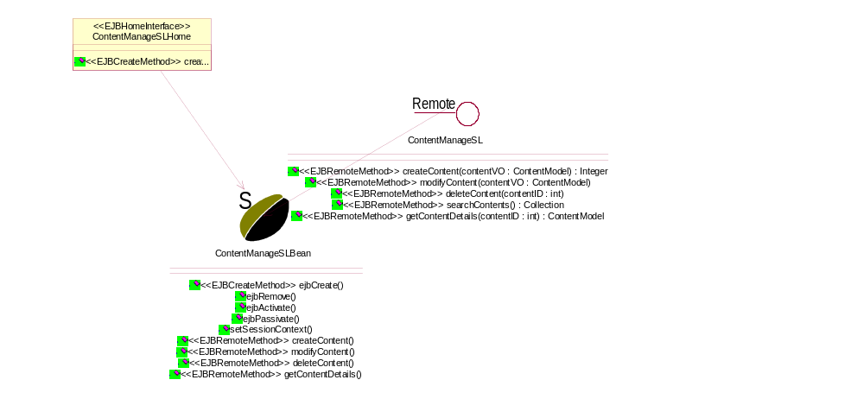

ContentManageSL

Remote Interface of Content Session Bean.

Public Operations:

createContent ( contentVO : ContentModel) : Integer

contentVO
contentmodel from web.

modifyContent ( contentVO : ContentModel) :

contentVO
Content Model for Modify,it should include non-null content_id field.

deleteContent ( contentID : int) :

delete one of the existing ContentModel by invoking ContentEBHome remove method.But the one must have no associate in ProjectContent table.

contentID
ContentID's int value to indicate ContentModel to remove.

searchContents () : Collection

return Contents collections as query clause.
ps:return type is unsure.

getContentDetails ( contentID : int) : ContentModel

return detail information of a Content by its contentID.

contentID
ContentID's int value.

ContentManageSLBean

stateless bean to control ContentModel by ContentEntity.

Public Operations:

ejbCreate () : void

ejbRemove () : void

ejbActivate () : void

ejbPassivate () : void

setSessionContext ( sc : SessionContext) : void

sc

createContent ( contentVO : ContentModel) : Integer

contentVO

modifyContent ( contentVO : ContentModel) :

contentVO

deleteContent ( contentID : int) :

contentID

getContentDetails ( contentID : int) : ContentModel

contentID

ContentManageSLHome

HomeInterface of Content Session Bean.

Public Operations:

create () : ContentManageSL

dao

ContentDAO

Content database access object.
Attention: all method are invoked by ejb entity but findByPK,so we needn't args,even primaryey value.findByPK is invoke by ejbFinder.

Derived from GeneralDAO

Public Operations:

create ( contentVO : ContentModel) : int

insert new ContentModel into database.

contentVO
ContentModel without PK of EntityBean.

store () :

invoke by ejbStore method of Entity Bean.

load () :

invoke by ejbLoad,keep syn between database and ejb object.

remove () :

remove ContentModel in database,invoke by ejbRemove.

getDetails () :

findByPK ( contentID : int) : Integer

return a valid ContentID.

contentID
ContentID's int value,maybe invalid.

ContentManageDAO
Search method Database access Object of content manage Bean.

Derived from GeneralDAO

Public Operations:

searchContents ( clause : String) : Collection

unsure return type.

clause
SQL clause,begin from "where" or "from".

ejb

Class Diagram - contentejb

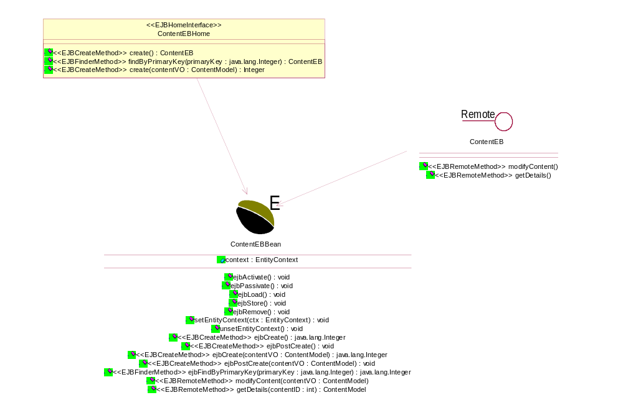

ContentEB
Remote Interface of Content Entity Bean.

Public Operations:

modifyContent ( contentVO : ContentModel) :

modify ContentModel detail in Database.

contentVO
ContentModel to modify,must include a valid ContentID.

getDetails ( contentID : int) : ContentModel

return Content Detail information by ContentID's int value.

contentID
ContentID's int value.

ContentEBBean

Entity Bean to describe ContentModel.

Derived from ContentModel

Public Attributes:

context : EntityContext

Public Operations:

ejbActivate () : void

ejbPassivate () : void

ejbLoad () : void

ejbStore () : void

ejbRemove () : void

setEntityContext ( ctx : EntityContext) : void

ctx

unsetEntityContext () : void

ejbCreate () : java.lang.Integer

ejbPostCreate () : void

ejbCreate ( contentVO : ContentModel) : java.lang.Integer

contentVO

ejbPostCreate ( contentVO : ContentModel) : void

contentVO

ejbFindByPrimaryKey ( primaryKey : java.lang.Integer) : java.lang.Integer

primaryKey

modifyContent ( contentVO : ContentModel) :

contentVO

getDetails ( contentID : int) : ContentModel

contentID

ContentEBHome

HomeInterface of Content Entity Bean.

Public Operations:

create () : ContentEB

findByPrimaryKey ( primaryKey : java.lang.Integer) : ContentEB

primaryKey

create ( contentVO : ContentModel) : Integer

contentVO

exceptions

model

ContentModel

This class represents the model date for the ProjectContent. Note that this object is immutable since it is intended to be read only.

Protected Attributes:

contentID : int

contentFileSize : int

contentName : String

contentDocURL : String

contentInfo : String

contentState : String

contentType : String

contentCreateTime : String

ContentCreateDate : String

contentModifyDate : String

contentModifyTime : String

contentCreatorID : int

contentModifierID : int

util

course

cortrol

CourseSL

Remote Interface of Course Session Bean.

Public Operations:

getCourseList () : vector

CourseSLBean

stateless bean to control CourseModel by CourseEntity.

Private Attributes:

dao : GeneralDAO

Public Operations:

ejbCreate () : void

ejbRemove () : void

ejbActivate () : void

ejbPassivate () : void

setSessionClass () : void

createCourse () : Integer

removenCourse () : void

modifyCourse () : void

searchCourse () : void

CourseSLHome

HomeInterface of Course Session Bean.

Public Operations:

create () : ClassSL

dao

CourseDAO

Database access object of UsersEBBean.

Public Operations:

create () : SchoolResourceEBBeanPK

load () : void

store () : void

remove () : void

findByPK () : SchoolResourceEBBeanPK

ejb

CourseEB

课程

Public Operations:

setAll () : void

CourseEBBean

EJB of CourseEBBean

Derived from CourseDAO

Public Attributes:

context : EntityContext

con : java.sql.Connection = null

ds : javax.sql.DataSource = null

Public Operations:

ejbCreate () : ExaminationscoreEBBeanPK

ejbPostCreate () : void

ejbActivate () : void

ejbPassivate () : void

ejbLoad () : void

ejbStore () : void

ejbRemove () : void

setEntityContext ( ctx : EntityContext) : void

ctx

unsetEntityContext () : void

ejbFindByPrimaryKey ( primaryKey : ExaminationscoreEBBeanPK) : ExaminationscoreEBBeanPK

primaryKey

CourseEBBeanPK
课程

Public Operations:

equals () : Boolean

getCourseID () : Integer

hashCode () : Integer

setCourseID () : void

CourseEBHome

The home interface of the Course EJB.

Public Operations:

create () : ExaminationscoreEB

findByPrimaryKey ( primaryKey : ExaminationscoreEBBeanPK) : ExaminationscoreEB

primaryKey

model

CourseModel

Entity Bean to describe CourseModel

Private Attributes:

CourseID : Integer

CourseName : String

Teacher : Integer

StartDate : String

EndDate : String

Info : String

State : String

Allow : String

CreateDate : String

CreateTime : String

CreateBy : Integer

LastModifyDate : String

LastModifyTime : String

LastModifyBy : Integer

Public Operations:

getCourseID () : Integer

获得课程ID

getCourseName () : String

获得课程名称

getTeacher () : Integer

获得教师

getStartDate () : String

获得开始时间

getEndDate () : String

获得结束日期

getInfo () : String

获得说明

getState () : String

获得状态

getAllow () : String

获得允许禁止标志

getCreateDate () : String

获得创建日期

getCreateTime () : String

获得创建时间

getCreateBy () : Integer

获得创建人

getLastModifyDate () : String

获得修改日期

getLastModifyTime () : String

获得修改时间

getLastModifyBy () : Integer

获得修改人

setCourseName ( ProjectID : Integer) : void

设置课程名

ProjectID

setTeacher ( Student : Integer) : void

设置教师

Student

setStartDate () : void

设置开始时间

setEndDate () : void

设置结束日期

setInfo () : void

设置说明

setState ( Score : Integer) : void

设置状态

Score

setAllow ( Allow : String) : void

设置允许禁止标志

Allow

setCreateDate ( CreateDate : String) : void

设置创建日期

CreateDate

setCreateTime ( CreateTime : String) : void

设置创建时间

CreateTime

setLastModifyBy ( LastModifyBy : Integer) : void

设置创建人

LastModifyBy

coursestudent

cortrol

CourseStudentSL
Remote Interface of CourseStudent Session Bean.

Public Operations:

getCourseStudentList () : vector

CourseStudentSLBean

stateless bean to control CourseStudentModel by CourseStudentEntity.

Private Attributes:

dao : GeneralDAO

Public Operations:

ejbCreate () : void

ejbRemove () : void

ejbActivate () : void

ejbPassivate () : void

setSessionClass () : void

createCourseStudent () : Integer

removenCourseStudent () : void

modifyCourseStudent () : void

searchCourseStudent () : void

CourseStudentSLHome

HomeInterface of Course Session Bean.

Public Operations:

create () : ClassSL

dao

CourseStudentDAO

Database access object of CourseStudentEBBean.

Public Operations:

create () : com.dc.eschool.schoolresource.ejb.SchoolResourceEBBeanPK

store () : void

load () : void

remove () : void

findByPK () : SchoolResourceEBBeanPK

ejb

CourseStudentEB

班级组

Public Operations:

setAll ( SchoolResource : com.dc.eschool.schoolresource.model.SchoolResourceModel) : void

SchoolResource

CourseStudentEBBean

EJB of CourseStudentEBBean

Derived from SchoolResourceModel, SchoolResourceDAO

Public Attributes:

context : EntityContext

Private Attributes:

dao : com.dc.eschool.util.GeneralDAO

继承 GeneralDAO

Public Operations:

ejbCreate () : SchoolResourceEBBeanPK

ejbPostCreate () : void

ejbActivate () : void

ejbPassivate () : void

ejbLoad () : void

ejbStore () : void

ejbRemove () : void

setEntityContext ( ctx : EntityContext) : void

ctx

unsetEntityContext () : void

ejbFindByPrimaryKey ( primaryKey : SchoolResourceEBBeanPK) : SchoolResourceEBBeanPK

primaryKey

CourseStudentDAO () : void

继承 CourseStudentDAO

CourseStudentEBBeanPK

班级组

Public Operations:

equals ( obj : Object) : boolean

obj

getCourseStudentID () : int

hashCode () : int

setCourseStudentID ( newSchoolResourceID : int) : Void

newSchoolResourceID

CourseStudentEBHome

The home interface of the CourseStudent EJB.

Public Operations:

findByPrimaryKey ( primaryKey : SchoolResourceEBBeanPK) : SchoolResourceEB

primaryKey

create () : SchoolResourceEB

model

CourseStudentModel

Entity Bean to describe CourseStudentModel

Private Attributes:

CourseStudentID : Integer

Student : Integer

CourseID : Integer

Allow : String

CreateDate : String

CreateTime : String

CreateBy : Integer

LastModifyDate : String

LastModifyTime : String

LastModifyBy : Integer

Public Operations:

getCourseStudentID () : Integer

获得班级组ID

getStudent () : Integer

获得学生

getCourseID () : Integer

获得组别

getAllow () : String

获得允许，禁止标志

getCreateDate () : String

获得创建日期

getCreateTime () : String

获得创建时间

getCreateBy () : Integer

获得创建人

getLastModifyDate () : String

获得修改日期

getLastModifyTime () : String

获得修改时间

getLastModifyBy () : Integer

获得修改人

setStudent ( Name : String) : Void

设置学生

Name

setCourseID ( DocURL : String) : Void

设置组别

DocURL

setAllow ( SubjectID : Integer) : Void

设置允许，禁止标志

SubjectID

setCreateDate ( CreateDate : String) : Void

设置创建日期

CreateDate

setCreateTime ( CreateTime : String) : Void

设置创建时间

CreateTime

setCreateBy ( CreateBy : Integer) : Void

设置创建人

CreateBy

setLastModifyDate ( LastModifyDate : String) : Void
设置修改日期

LastModifyDate

setLastModifyTime ( LastModifyTime : String) : Void

设置修改时间

LastModifyTime

setLastModifyBy ( LastModifyBy : Integer) : Void

设置修改人

LastModifyBy

examinationscore

cortrol

ExaminationscoreSL

Public Operations:

getExaminationscoreList ( ExaminationscoreEBBeanPK : ExaminationscoreEBBeanPK) :

ExaminationscoreEBBeanPK

ExaminationscoreSLBean

Private Attributes:

dao : com.dc.eschool.util.GeneralDAO

extend of GeneralDAO

Public Operations:

ejbCreate () : void

ejbRemove () : void

ejbActivate () : void

ejbPassivate () : void

setSessionContext ( sc : SessionContext) : void

sc

ExaminationscoreSLHome

Public Operations:

create () : ExaminationscoreSL

dao

ExaminationScoreDAO

Database access object of ExaminationscoreEBBean.

Derived from GeneralDAO

Public Operations:

create () : com.dc.eschool.examinationscore.ejb.ExaminationscoreEBBeanPK

store () : void

load () : void

remove () : void

findByPK () : com.dc.eschool.examinationscore.ejb.ExaminationscoreEBBeanPK

ejb

ExaminationscoreEB

This interface provides methods to view and modify examinationscore information for a particular project.

Public Operations:

setAll ( ExaminationScore : com.dc.eschool.examinationscore.ExaminationScoreModel) : void

updates the examinationscore information for the specified project

ExaminationScore

ExaminationscoreEBBean

EJB of Examinationscore

Derived from ExaminationScoreDAO, ExaminationScoreModel, CourseDAO

Public Attributes:

context : EntityContext

Private Attributes:

dao : com.dc.eschool.util.GeneralDAO

extend GeneralDAO

Public Operations:

ejbCreate () : ExaminationscoreEBBeanPK

ejbPostCreate () : void

ejbActivate () : void

ejbPassivate () : void

ejbLoad () : void

ejbStore () : void

ejbRemove () : void

setEntityContext ( ctx : EntityContext) : void

ctx

unsetEntityContext () : void

ejbFindByPrimaryKey ( primaryKey : ExaminationscoreEBBeanPK) : ExaminationscoreEBBeanPK

primaryKey

ExaminationScoreDAO () : void

extend ExaminationScoreDAO

ExaminationscoreEBBeanPK

Public Operations:

equals ( obj : Object) : Boolean

obj

getExaminationScoreID () : Integer

hashCode () : int

setExaminationScoreID ( newExaminationScoreID : int) : int

newExaminationScoreID

ExaminationscoreEBHome

HomeInterface of Examinationscore Entity Bean.

Public Operations:

create () : ExaminationscoreEB

findByPrimaryKey ( primaryKey : ExaminationscoreEBBeanPK) : ExaminationscoreEB

primaryKey

model

ExaminationScoreModel

Entity Bean to describe ExaminationScoreModel

Private Attributes:

ExaminationID : Integer

ProjectID : Integer

Student : Integer

Score : Integer

Allow : String

CreateDate : String

CreateTime : String

CreateBy : Integer

LastModifyDate : String

LastModifyTime : String

LastModifyBy : Integer

Public Operations:

getExaminationID () : Integer

get of examinationid

getProjectID () : Integer

get of projectid

getStudent () : Integer

get of studentid

getScore () : Integer

get of score

getAllow () : String

get of allow

getCreateDate () : String

get of createdate

getCreateTime () : String

get of createtime

getCreateBy () : Integer

get of createby

getLastModifyDate () : String

get of lastmodifydate

getLastModifyTime () : String

get of lastmodifytime

getLastModifyBy () : Integer

get of lastmodifyby

setProjectID ( ProjectID : Integer) : void

update of projectid

ProjectID

setStudent ( Student : Integer) : void

update of studentid

Student

setScore ( Score : Integer) : void

update of score

Score

setAllow ( Allow : String) : void

update of allow

Allow

setCreateDate ( CreateDate : String) : void

update of createdate

CreateDate

setCreateTime ( CreateTime : String) : void

update of createtime

CreateTime

setCreateBy ( CreateBy : Integer) : void

update of createby

CreateBy

setLastModifyDate ( LastModifyDate : String) : void

update of lastmodifydate

LastModifyDate

setLastModifyTime ( LastModifyTime : String) : void

update of lastmodifytime

LastModifyTime

setLastModifyBy ( LastModifyBy : Integer) : void
update of lastmodifyby

LastModifyBy

homework

controll

HomeworkSL

This is the session facade for the Homework component. This is implemented
as a stateless session bean which exports interfaces of the Homework components

Public Operations:

createHomework () : void

Add data to homework table.

removeHomework () : void

Delete data from homework table.

modifyHomework () : void

Modify homework data.

searchHomeworks () : void

Search data from homework table.

getDetails ( homeworkId : String) : homeworkModel

Gets the homework details give a homework id
@param homeworkId a string that represents the homework Id
@return the <code>HomeworkModel</code> that has the Homework information
corresponding to a homework's detail.
@throws <code>RemoteException</code> for irrecoverable errors
@throws <code>FinderException</code> if the user details was not found

homeworkId

HomeworkSLBean

Session Bean implementation for HomeworkSLEJB, a stateless sessionbean.

Public Operations:

getHomeworks () : ListChunk

HomeworkSLEJB () :

Constructor - does nothing

ejbCreate () : void

the ejbCreate methods that just gets the references

ejbRemove () : void

the ejbRemove methods that does nothing

ejbActivate () : void

the ejbActivate methods that just gets the references

ejbPassivate () : void

the ejbPassivate methods that resets the references

setSessionContext ( sc : SessionContext) : void

Sets the session context
@param sc the <code>SessionContext</code> for this instance

sc

destroy () : void

searchHomeworks () :

createHomework () :

removeHomework () :

modifyHomework () :

getDetails () : void

HomeworkSLHome

The home interface of the Homework(Stateless Sessionbean).

Public Operations:

create () : HomeworkSL

dao

HomeworkContentManageDAO

HomeworkContentManageDAO is an interface for the Data Access Object (DAO).
This interface encapsulates all the JDBC calls made by the HomeworkContentSLBean.
The actual logic of fetching the data in relational database tables to mirror the state of HomeworkContentSLBean

Derived from GeneralDAO

Public Operations:

searchHomeworkContents () : Collection

HomeworkDAO

Database access object of HomeworkEntityBean.

Derived from GeneralDAO

Public Operations:

create () :

store () :

load () :

findByPK ( homeworkID : int) :

homeworkID

getDetails () : HomeworkModel

HomeworkManageDAO

HomeworkManageDAO is an interface for the Data Access Object (DAO).
This interface encapsulates all the JDBC calls made by the HomeworkSLBean.
The actual logic of fetching the data in relational database tables to mirror the state of HomeworkSLBean

Derived from GeneralDAO

Public Operations:

getDetails ( homeworkId : String) : homeworkModel

Gets the homework details give a homework id
@param homeworkId a string that represents the homework Id
@return the <code>HomeworkModel</code> that has the Homework information
corresponding to a homework's detail.
@throws <code>RemoteException</code> for irrecoverable errors
@throws <code>FinderException</code> if the user details was not found

homeworkId

searchHomeworks () :

ejb

HomeworkEB

This is the session facade for the Homework component. This is implemented as a entity bean which exports interfaces of the Homework components

Public Operations:

getDetails () : HomeworkModel

Gets the homework details give a homeworkContent id
@param homeworkContentId a string that represents the homework Id
@return the <code>HomeworkContentModel</code> that has the HomeworkContent information
corresponding to a homeworkContent's detail.

modifyDetails () : void

Gets the homework details give a homeworkContent id
@param homeworkContentId a string that represents the homework Id
@return the <code>HomeworkContentModel</code> that has the HomeworkContent information
corresponding to a homeworkContent's detail.

HomeworkEBBean

Entity Bean implementation for HomeworkEBBean

Derived from HomeworkModel

Public Attributes:

EJB_Context : javax.ejb.EntityContext

EJB_Context : javax.ejb.EntityContext

Public Operations:

HomeworkEBBeanEJB () :

ejbCreate () : HomeworkEBPK

the ejbCreate methods that just gets the references

ejbPostCreate () : void

ejbActivate () : void

the ejbActivate methods that just gets the references

ejbPassivate () : void

the ejbPassivate methods that resets the references

ejbLoad () : void

ejbStore () : void

ejbRemove () : void

setEntityContext ( ctx : javax.ejb.EntityContext, ctx : javax.ejb.EntityContext) : void

ctx

ctx

unsetEntityContext () : void

ejbFindByPrimarykey () : void

getDetails () : HomeworkModel

Gets the homework details give a homeworkContent id
@param homeworkContentId a string that represents the homework Id
@return the <code>HomeworkContentModel</code> that has the HomeworkContent information
corresponding to a homeworkContent's detail.

modifyDetails () : void

HomeworkEBBean () :

Constractor

HomeworkEBHome

The home interface of the HomeworkEBBean.

Public Operations:

findByPrimaryKey ( primaryKey : HomeworkEBPK) : HomeworkEB

primaryKey

create () : HomeworkEB

HomeworkEBPK

Public Operations:

hashCode () : int

equals () : boolean

toString () : java.lang.String

list

HomeworkTag

The Tag of homework

Derived from ListTag

Private Attributes:

homework : String = null

hasNext : boolean

Public Operations:

setHomewrok ( homework : String) : void

homework

setNumItems ( numItemsStr : String) : void

numItemsStr

setStartIndex ( startIndexStr : String) : void

startIndexStr

Protected Operations:

initParamPrefix () : void

findCollection () : Collection

needsNextForm () : void

ListTag

* ListTag
* -------
* This is a base class for a list tag that provides a next and prev
* functionality. It can be extended to support lists with any kind of item
* object. It works in conjunction with ItemsTag, NextFormTag, PrevFormTag
* and some extension of ItemAttributeTag.
*
* This is the outermost list tag and essentially just creates and maintains
* the iterator for the ItemsTag. How the collection of items is created is
* implemented by the extension of this tag. This tag determines whether next
* and prev forms should appear.
*
* It also maintains a number of other variables for the inner tags to refer
* to, including startIndex, numItems, hasNextForm and hasPrevForm, and the
* parameter names for the next, prev, and startIndex hidden inputs which
* appear in the next and prev forms. The values of these parameters are
* stored here as well and are actually retrieved from the session object
* rather than the request object. These are stored there by the ListHandler
* request handler. So, any page in which a list tag appears must use that
* request handler (specified in requestmappings.xml).

Protected Attributes:

collection : Collection

paramPrefix : String

this should be initialized in initParamPrefix

numItems : int = -1

tag attributes

startIndex : int = 1

tag attributes

NEXT_PARAM : String = "next"

constants

PREV_PARAM : String = "prev"

constants

STARTINDEX_PARAM : String = "startindex"

nextParamValue : String = null

parameter values retrieved from session object

prevParamValue : String = null

hasNextForm : boolean = true

other variables referred to by inner tags

iterator : java.util.Iterator

Private Attributes:

hasPrevForm : boolean = false

Public Operations:

doStartTag () : int

doEndTag () : int

getParamPrefix () : String

getNumItems () : int

getStartIndex () : int

getStartIndexParam () : String

getNextParam () : String

getPrevParam () : String

hasNextForm () : boolean

hasPrevForm () : boolean

getIterator () : Iterator

setNumItems ( numItemsStr : String) : void

numItemsStr

setStartIndex ( startIndexStr : String) : void

startIndexStr

Protected Operations:

initParamPrefix () : void

findCollection () : Collection

needsNextForm () : void

model

HomeworkModel

This class represents the model date for the Homework. Note that this object is immutable since it is intended to be read only.

Private Attributes:

homeworkID : Integer

student : Integer

projectID : Integer

allow : String

createData : String

createTime : String

createBy : Integer

lastModifyData : String

This class represents the model date for the Homework. Note that this object is immutable since it is intended to be read only.

lastModifyTime : String

lastModifyBy : Integer

ListChunk

Private Attributes:

totalElement : int

elementInThisList : Collection

firstElementOfThisList : int

countOfElementsInthisList : int

Public Operations:

getCollection () : Collection

ListChunk ( count : int, coll : Collection, first : int, curCount : int) :

count

coll

first

curCount

getTotalCount () : int

getCurrentCount () : int

getFirstElementIndex () : int

web

HomeworkWebImpl

Web tier of Homework(Homework Javabean)

Private Attributes:

dao : HomeworkManageDAO

Public Operations:

HomeworkWebImpl () :

Constractor

searchHomeworks () :

getDetails ( homeworkId : String) : homeworkModel

Gets the homework details give a homework id
@param homeworkId a string that represents the homework Id
@return the <code>HomeworkModel</code> that has the Homework information
corresponding to a homework's detail.

homeworkId

homeworkContent

controll

HomeworkContentSL

This is the session facade for the HomeworkContent component. This is implemented as a stateless session bean which exports interfaces of the HomeworkContent components

Public Operations:

createHomeworkContent () :

removeHomeworkContent () :

modifyHomeworkContent () :

searchHomeworkContent () :

getDetails () : HomeworkContentModel

Gets the homeworkContent details give a homework id
@param homeworkContentId a string that represents the homework Id
@return the <code>HomeworkContentModel</code> that has the HomeworkContent information
corresponding to a homeworkcontent's detail.

HomeworkContentSLBean

Stateless sessionbean of HomeworkContent

Public Attributes:

EJB_Context : javax.ejb.SessionContext = null

Public Operations:

HomeworkContentSLBean () :

Constractor

ejbCreate () : void

the ejbCreate methods that just gets the references

ejbRemove () : void

the ejbRemove methods that just delete the data

ejbActivate () : void

the ejbActivate methods that just gets the references

ejbPassivate () : void

the ejbPassivate methods that resets the references

setSessionContext ( sc : javax.ejb.SessionContext) : void

Sets the session context
@param sc the <code>SessionContext</code> for this instance

sc

createHomeworkContent () :

removeHomeworkContent () :

the ejbRemove methods that does nothing

modifyHomeworkContent () :

searchHomeworkContents () :

@return the HomeworkContent information corresponding to the search text.

getDetails () : HomeworkContentModel

Gets the homeworkContent details give a homework id
@param homeworkContentId a string that represents the homework Id
@return the <code>HomeworkContentModel</code> that has the HomeworkContent information
corresponding to a homeworkcontent's detail.

HomeworkContentSLHome

The home interface of the HomeworkContentSLBean

Public Operations:

create () : HomeworkContentSL

dao

HomeworkContentDAO

Database access object of HomeworkCotentEntityBean.

Derived from GeneralDAO

Public Operations:

create () :

store () :

remove () :

load () :

findByPK () :

getDetails () :

ejb

HomeworkContentEB

This is implemented as a entity session bean which exports interfaces of the HomeworkContent components

Public Operations:

getDetails () : HomeworkContent

modifyDetails () : void

HomeworkContentEBBean

Entity Bean implementation for HomeworkContentEBBean

Derived from HomeworkContentModel

Public Attributes:

EJB_Context : javax.ejb.EntityContext

Public Operations:

HomeworkContentEBBean () :

Constractor

ejbCreate () : HomeworkContentEBPK

ejbPostCreate () : void

getDetails () : HomeworkContentModel

modifyDetails () : void

ejbFindByPrimaryKey () : void

ejbActivate () : void

ejbPassivate () : void

ejbLoad () : void

ejbStore () : void

ejbRemove () : void

setEntityContext ( ctx : javax.ejb.EntityContext) : void

ctx

unsetEntityContext () : void

HomeworkContentEBHome

The home interface of the HomeworkContentEBBean

Public Operations:

create () : HomeworkContentEB

findByPrimaryKey ( primaryKey : HomeworkContentEBPK) : HomeworkContentEB

primaryKey

HomeworkContentEBPK

Public Operations:

hashCode () : int

equals () : boolean

toString () : java.lang.String

model

HomeworkContentModel

This class represents the model date for the HomeworkContent. Note that this object is immutable since it is intended to be read only.

Private Attributes:

homewrokContentID : Integer

docURL : String

state : String

submitData : String

submitTime : String

passData : String

passTime : String

homeWorkID : Integer

createData : String

createTime : String

createBy : Integer

lastModifyData : String

lastModifyTime : String

lastModifyBy : Integer

project

Class Diagram - ProjectEjbClass

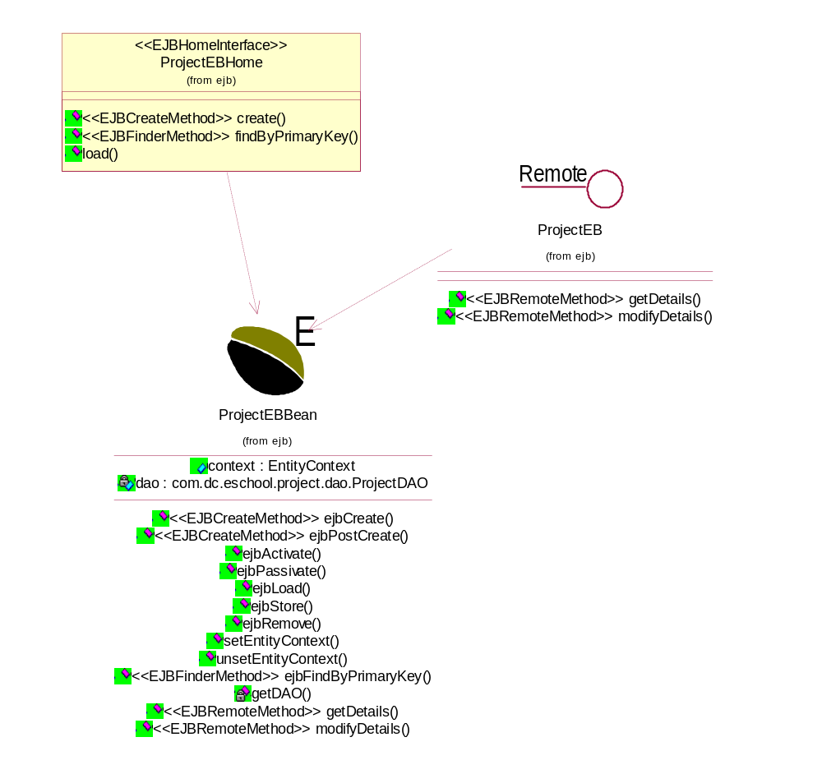

controll

ProjectManageSL

This is the session facade for the project component. This is implemented as a session bean which exports interfaces of the Project components

Public Operations:

createProject () : int

removeProject () :

modifyProject () :

searchProjects () : Collection

@return the project information corresponding to the search text.

getDetails () : ProjectModel

updates the project information for the specified project

ProjectManageSLBean

Implementation of Project as a Stateless Session Bean

Private Attributes:

projetHome :

Public Operations:

ejbCreate () : void

the ejbCreate methods that just gets the references

ejbRemove () : void

ejbActivate () : void

the ejbActivate methods that just gets the references

ejbPassivate () : void

the ejbPassivate methods that resets the references

setSessionContext ( sc : SessionContext) : void

Sets the session context
@param sc the <code>SessionContext</code> for this instance

sc

createProject () : int

removeProject () :

the ejbRemove methods that does nothing

modifyProject () :

searchProjects () : Collection

@return the project information corresponding to the search text.

ProjectManageSLHome

The home interface of the Project stateless sessionbean

Public Operations:

create () : ProjectManageSL

dao

ProjectDAO

Database access object of ProjectEntityBean.others same as ContentDAO.

Derived from GeneralDAO

Public Operations:

create () :

store () :

remove () :

load () :

findByPK ( projectID : int) : Integer

projectID

getDetails () :

ProjectManageDAO

ProjectManageDAO is an interface for the Data Access Object (DAO).
This interface encapsulates all the JDBC calls made by the ProjectManageSLBean.
The actual logic of fetching the data in relational database tables to mirror the state of ProjectManageSLBean

Derived from GeneralDAO

Public Operations:

searchProjects () : Collection

ejb

ProjectEB

This interface provides methods to view and modify project information for a particular project such as test.

Public Operations:

getDetails () : ProjectModel

@return the project information corresponding to this project.

modifyDetails () :

updates the project information for the specified project

ProjectEBBean

Implementation of account as an Entity Bean

Derived from ProjectModel

Public Attributes:

context : EntityContext

Private Attributes:

dao : com.dc.eschool.project.dao.ProjectDAO

Public Operations:

ejbCreate () : java.lang.Integer

Add data to project table

ejbPostCreate () : void

ejbActivate () : void

ejbPassivate () : void

ejbLoad () : void

ejbStore () : void

ejbRemove () : void

setEntityContext ( ctx : EntityContext) : void

ctx

unsetEntityContext () : void

ejbFindByPrimaryKey ( primaryKey : java.lang.Integer) : java.lang.Integer

find by primaryKey

primaryKey

getDetails () : ProjectModel

@return the project information corresponding to this project.

modifyDetails () :

updates the project information for the specified project

Private Operations:

getDAO () : GeneralDAO

ProjectEBHome

The home interface of the Project EJB

Public Operations:

create () : ProjectEB

findByPrimaryKey ( primaryKey : java.lang.Integer) : ProjectEB

primaryKey

load () :

exceptions

ProjectDAOException

model

ProjectModel

This class represents the model date for the project. Note that this object is immutable since it is intended to be read only.

Protected Attributes:

projectID : int

projectName : String = null

courseID : int

projectInfo : String

projectState : String

projectType : String

isPublishResult : boolean = false

projectStartDate : String

projectEndDate : String

projectCreateDate : String

projectCreateTime : String

projectModifyDate : String

projectModifyTime : String

projectCreatorID : int

projectModifierID : int

contentItems : Collection = new ArrayList()

Public Operations:

getProjectID () : int

getProjectName () : String

getCourseID () : int

getProjectInfo () : String

getProjectState () : String

getProjectType () : String

util

projectcontent

ProjectContModel

This class represents the model date for the project and content. Note that this object is immutable since it is intended to be read only.

Protected Attributes:

projContID : int

contentID : int

projectID : int

projContCreateDate : String

projContCreateTime : String

projContCreatorID : int

projContModifyDate : String

This class represents the model date for the ProjectContent. Note that this object is immutable since it is intended to be read only.

projContModifyTime : String

projContModifierID : int

schoolresource

cortrol

SchoolResourceSL

Public Operations:

getSchoolResourceList ( SchoolResourceEBBeanPK : SchoolResourceEBBeanPK) : vector

detail list of the schoolresource information for the specified project

SchoolResourceEBBeanPK

SchoolResourceSLBean

Session Bean of SchoolResource

Derived from SchoolResourceEBBean

Private Attributes:

dao : com.dc.eschool.util.GeneralDAO

extend GeneralDAO

Public Operations:

ejbCreate () : void

ejbRemove () : void

ejbActivate () : void

ejbPassivate () : void

setSessionContext ( sc : SessionContext) : void

sc

SchoolResourceSLHome

Public Operations:

create () : SchoolResourceSL

dao

SchoolResourceDAO

Database access object of SchoolResourceEBBean.

Derived from GeneralDAO

Public Operations:

create () : com.dc.eschool.schoolresource.ejb.SchoolResourceEBBeanPK

store () : void

load () : void

remove () : void

findByPK () : SchoolResourceEBBeanPK

ejb

SchoolResourceEB

This interface provides methods to view and modify schoolresource information for a particular project.

Public Operations:

setAll ( SchoolResource : com.dc.eschool.schoolresource.model.SchoolResourceModel) : void

updates the schoolresource information for the specified project

SchoolResource

SchoolResourceEBBean

EJB of SchoolResourceEBBean

Derived from SchoolResourceModel, SchoolResourceDAO

Public Attributes:

context : EntityContext

Private Attributes:

dao : com.dc.eschool.util.GeneralDAO

extend GeneralDAO

Public Operations:

ejbCreate () : SchoolResourceEBBeanPK

ejbPostCreate () : void

ejbActivate () : void

ejbPassivate () : void

ejbLoad () : void

ejbStore () : void

ejbRemove () : void

setEntityContext ( ctx : EntityContext) : void

ctx

unsetEntityContext () : void

ejbFindByPrimaryKey ( primaryKey : SchoolResourceEBBeanPK) : SchoolResourceEBBeanPK

primaryKey

SchoolResourceDAO () : void

extend SchoolResourceDAO

setAll () :

updates the schoolresource information for the specified project

SchoolResourceEBBeanPK

Public Operations:

equals ( obj : Object) : boolean

obj

getSchoolResourceID () : String

hashCode () : int

setSchoolResourceID ( newSchoolResourceID : int) : Void

newSchoolResourceID

SchoolResourceEBHome

HomeInterface of SchoolResource Entity Bean.

Public Operations:

findByPrimaryKey ( primaryKey : SchoolResourceEBBeanPK) : SchoolResourceEB

primaryKey

create () : SchoolResourceEB

model

SchoolResourceModel

Entity Bean to describe SchoolResourceModel

Private Attributes:

SchoolResourseID : Integer

Name : String

DocURL : String

SubjectID : Integer

StartDate : String

EndDate : String

CreateDate : String

CreateTime : String

CreateBy : Integer

LastModifyDate : String

LastModifyTime : Integer

LastModifyBy : Integer

Public Operations:

getSchoolResourseID () : Integer

get of schoolresourceID

getName () : String

get of name

getDocURL () : String

get of docurl

getSubjectID () : Integer

get of subjectid

getStartDate () : String

get of startdate

getEndDate () : String

get of enddate

getAllow () : String

get of allow

getCreateDate () : String

get of createdate

getCreateTime () : String

get of createtime

getCreateBy () : Integer

get of createby

getLastModifyDate () : String

get of lastmodifydate

getLastModifyTime () : String

get of lastmodifytime

getLastModifyBy () : Integer

get of lastmodifyby

setName ( Name : String) : Void

update of name
Name

setDocURL ( DocURL : String) : Void

update of docurl

DocURL

setSubjectID ( SubjectID : Integer) : Void

update of subjectid

SubjectID

setStartDate ( StartDate : String) : Void

update of startdate

StartDate

setEndDate ( EndDate : String) : Void

update of enddate

EndDate

setAllow ( Allow : String) : Void

update of allow

Allow

setCreateDate ( CreateDate : String) : Void

update of createdate

CreateDate

setCreateTime ( CreateTime : String) : Void

update of createtime

CreateTime

setCreateBy ( CreateBy : Integer) : Void

update of createby

CreateBy

setLastModifyDate ( LastModifyDate : String) : Void

update of lastmodifydate
LastModifyDate

setLastModifyTime ( LastModifyTime : String) : Void

update of lastmodifytime

LastModifyTime

setLastModifyBy ( LastModifyBy : Integer) : Void

update of lastmodifyby

LastModifyBy

scorestatistic

cortrol

ScorestatisticsSL

Public Operations:

getScoreStatistic ( Answer : String, studentAnswer : String) :

Answer

studentAnswer

ScorestatisticsSLBean

Private Attributes:

dao : com.dc.eshool.util.GeneralDAO

extend of GeneralDAO

Public Operations:

ejbCreate () : void

ejbRemove () : void

ejbActivate () : void

ejbPassivate () : void

setSessionContext ( sc : SessionContext) : void

sc

ScorestatisticsSLHome

Public Operations:

create () : ScorestatisticsSL

dao

ScorestatisticDAO

Database access object of ScorestatisticEBBean.

Derived from GeneralDAO

Public Operations:

create () : com.dc.eschool.scorestatistic.ejb.ScorestatisticsEBBeanPK

store () : void

load () : void

remove () :

findByPK () : com.dc.eschool.scorestatistic.ejb.ScorestatisticsEBBeanPK

ejb

ScorestatisticsEB

This interface provides methods to view and modify scorestatistics information for a particular project.

Public Operations:

setAll ( Scorestatistics : com.dc.eschool.scorestatistics.model.ScorestatisticsModel) : void

updates the scorestatistics information for the specified project

Scorestatistics

ScorestatisticsEBBean

EJB of Scorestatistics

Derived from ScorestatisticDAO, ScoreStatisticsModel, AnswerItemEBBean, SubjectDAO

Public Attributes:

context : EntityContext

Private Attributes:

dao : com.dc.eschool.util.GeneralDAO

extend GeneralDAO

Public Operations:

ejbCreate () : ScorestatisticsEBBeanPK

ejbPostCreate () : void

ejbActivate () : void

ejbPassivate () : void

ejbLoad () : void

ejbStore () : void

ejbRemove () : void

setEntityContext ( ctx : EntityContext) : void

ctx

unsetEntityContext () : void

ejbFindByPrimaryKey ( primaryKey : ScorestatisticsEBBeanPK) : ScorestatisticsEBBeanPK

primaryKey

ScorestatisticDAO () : void

extend ScorestatisticDAO

ScorestatisticsEBBeanPK

Public Operations:

equals ( obj : Object) : Boolean

obj

getScorestatisticsID () : Integer

hashCode () : int

setScorestatisticsID ( newScorestatisticsID : int) : int

newScorestatisticsID

ScorestatisticsEBHome

HomeInterface of Scorestatistics Entity Bean.

Public Operations:

create () : ScorestatisticsEB

findByPrimaryKey ( primaryKey : ScorestatisticsEBBeanPK) : ScorestatisticsEB

primaryKey

model

ScoreStatisticsModel

Entity Bean to describe ScoreStatisticsModel

Private Attributes:

ScoreStatisticID : Integer

Student : Integer

AnswerItemID : Integer

ProjectContentID : Integer

Statistic : String

RightAnswer : Integer

WrongAnswer : Integer

Allow : String

CreateDate : String

CreateTime : String

CreateBy : Integer

LastModifyDate : String

LastModifyTime : String

LastModifyBy : Integer

Public Operations:

getSoreStatisticID () : Integer

get of sorestatisticsid

getStudent () : Integer

get of studentid

getAnswerItemID () : Integer

get of answeritemid

getProjectContentID () : Integer

get of projectcontentid

getStatistic () : String

get of statistic

getRightAnswer () : Integer

get of rightanswer

getWrongAnswer () : Integer

get of wronganswer

getAllow () : Integer

get of allow

getCreateDate () : String

get of createdate

getCreateTime () : String

get of createtime

getCreateBy () : Integer

get of createby

getLastModifyDate () : String

get of lastmodifydate

getLastModifyTime () : String

get of lastmodifytime

getLastModifyBy () : Integer

get of lastmodifyby

setStudent ( Student : Integer) : void

update of studentid

Student

setAnswerItemID ( AnswerItemID : Integer) : void

update of answeritemid

AnswerItemID

setProjectContentID ( ProjectContentID : Integer) : void

update of projectcontentid

ProjectContentID

setStatistic ( Statistic : String) : void

update of statistic

Statistic

setRightAnswer ( RightAnswer : Integer) : void

update of rightanswer

RightAnswer

setWrongAnswer ( WrongAnswer : Integer) : void

update of wronganswer

WrongAnswer

setAllow ( Allow : String) : void

update of allow

Allow

setCreateDate ( CreateDate : String) : void

update of createdate

CreateDate

setCreateTime ( CreateTime : String) : void

update of createtime

CreateTime

setCreateBy ( CreateBy : Integer) : void

update of createby

CreateBy

setLastModifyDate ( LastModifyDate : String) : void

update of lastmodifydate

LastModifyDate

setLastModifyTime ( LastModifyTime : String) : void

update of lastmodifytime

LastModifyTime

setLastModifyBy ( LastModifyBy : Integer) : void

update of lastmodifyby

LastModifyBy

subject

cortrol

SubjectSL

Remote Interface of Subject Session Bean.

Public Operations:

getSubjectList () : vector

SubjectSLBean

stateless bean to control SubjectModel by SubjectEntity.

Private Attributes:

dao : GeneralDAO

Public Operations:

ejbCreate () : void

ejbRemove () : void

ejbActivate () : void

ejbPassivate () : void

setSessionClass () : void

createSubject () : Integer

removenSubject () : void

modifySubject () : void

searchSubject () : void

SubjectSLHome
HomeInterface of Course Session Bean.

Public Operations:

create () : ClassSL

dao

SubjectDAO

Database access object of SubjectEBBean.

Public Operations:

create () : ScorestatisticsEBBeanPK

store () : void

load () : void

remove () : void

findByPK () : ScorestatisticsEBBeanPK

ejb

SubjectEB

科目

Public Operations:

setAll () : void

SubjectEBBean
EJB of SubjectEBBean

Derived from SubjectDAO

Public Attributes:

context : EntityContext

con : java.sql.Connection = null

ds : javax.sql.DataSource = null

Public Operations:

ejbCreate () : ScorestatisticsEBBeanPK

ejbPostCreate () : void

ejbActivate () : void

ejbPassivate () : void

ejbLoad () : void

ejbStore () : void

ejbRemove () : void

setEntityContext ( ctx : EntityContext) : void

ctx

unsetEntityContext () : void

ejbFindByPrimaryKey ( primaryKey : ScorestatisticsEBBeanPK) : ScorestatisticsEBBeanPK

primaryKey

SubjectEBBeanPK

科目

Public Operations:

equals () : Boolean

getSubjectID () : Integer

hashCode () : Integer

setSubjectID () : void

SubjectEBHome

The home interface of the Subject EJB.

Public Operations:

create () : ScorestatisticsEB

findByPrimaryKey ( primaryKey : ScorestatisticsEBBeanPK) : ScorestatisticsEB

primaryKey

model

SubjectModel

Entity Bean to describe SubjectModel

Private Attributes:

SubjectID : Integer

Name : String

Allow : String

CreateDate : String

CreateTime : String

CreateBy : Integer

LastModifyDate : String

LastModifyTime : String

LastModifyBy : Integer

Public Operations:

getSubjectID () : Integer

获得科目ID

getName () : String

获得分类科目名

getAllow () : String

获得允许禁止标志

getCreateDate () : String

获得创建日期

getCreateTime () : String

获得创建时间

getCreateBy () : Integer

获得创建人

getLastModifyDate () : String

获得修改日期

getLastModifyTime () : String

获得修改时间

getLastModifyBy () : Integer

获得修改人

setName ( Student : Integer) : void

设置分类科目名

Student

setAllow ( Allow : String) : void

设置允许禁止标志

Allow

setCreateDate ( CreateDate : String) : void

设置创建日期

CreateDate

setCreateTime ( CreateTime : String) : void

设置创建时间

CreateTime

setCreateBy ( CreateBy : Integer) : void

设置创建人

CreateBy

setLastModifyDate ( LastModifyDate : String) : void

设置修改日期

LastModifyDate

setLastModifyTime ( LastModifyTime : String) : void

设置修改时间

LastModifyTime

setLastModifyBy ( LastModifyBy : Integer) : void

设置修改人

LastModifyBy

testresultsitem

cortrol

TestResultsItemSL

Public Operations:

getTestResultsItemList ( TestResultsItemPK : com.dc.eschool.testresultsitem.ejb.TestResultsItemPK) :

detail list of the testresultsitem information for the specified project

TestResultsItemPK

TestResultsItemSLBean

extend of GeneralDAO

Private Attributes:

dao : com.dc.eschool.util.GeneralDAO

Public Operations:

ejbCreate () : void

ejbRemove () : void

ejbActivate () : void

ejbPassivate () : void

setSessionContext ( sc : SessionContext) : void

sc

TestResultsItemSLHome

Public Operations:

create () : TestResultsItemSL

dao

TestResultsItemDAO

Database access object of TestResultsItemEBBean.

Derived from GeneralDAO

Public Operations:

creat () : com.dc.eschool.testresultsitem.ejb.TestResultsItemEBBeanPK

store () : void

load () : void

remove () : void

findByPK () : com.dc.eschoolresource.testresultsitem.ejb.TestResultsItemEBBeanPK

ejb

TestResultsItemEB

This interface provides methods to view and modify testresultsitem information for a particular project.

Public Operations:

setAll ( testresultsitem : com.dc.eschool.testresultsitem.ejb.TestResultsItemModel) : void

updates the testresultsitem information for the specified project

testresultsitem

TestResultsItemEBBean

EJB of TestResultsItemEBBean

Derived from TestResultsItemDAO, TestResultsItemModel

Public Attributes:

context : EntityContext

Private Attributes:

dao : com.dc.eschool.util.GeneralDAO

extend GeneralDAO

Public Operations:

ejbCreate () : TestResultsItemEBBeanPK

ejbPostCreate () : void

ejbActivate () : void

ejbPassivate () : void

ejbLoad () : void

ejbStore () : void

ejbRemove () : void

setEntityContext ( ctx : EntityContext) : void

ctx

unsetEntityContext () : void

ejbFindByPrimaryKey ( primaryKey : TestResultsItemEBBeanPK) : TestResultsItemEBBeanPK

primaryKey

TestResultslItemDAO () : void

extend TestResultslItemDAO

TestResultsItemEBBeanPK

Public Operations:

equals ( obj : Object) : Boolean

obj

getSchoolResourceID () : Integer

hashCode () : int

setSchoolResourceID ( newschoolResourceID : int) : int

newschoolResourceID

TestResultsItemEBHome

HomeInterface of TestResultsItem Entity Bean.

Public Operations:

create () : TestResultsItemEB

findByPrimaryKey ( primaryKey : TestResultsItemEBBeanPK) : TestResultsItemEB

primaryKey

model

TestResultsItemModel

Entity Bean to describe TestResultsItemModel

Private Attributes:

TestResultItemID : Integer

Student : Integer

Right : String

AnswerMark : String

ExaminationID : Integer

Answer : String

AnswerItemID : Integer

Allow : String

CreateDate : String

CreateTime : String

CreateBy : Integer

LastModifyDate : String

LastModifyTime : String

LastModifyBy : Integer

Public Operations:

getTestResultItemID () : Integer

get of testresultitemid

getStudent () : Integer

get of studentid

getRight () : String

get of right

getAnswerMark () : String

get of answermark

getExaminationID () : Integer

get of examinationid

getAnswer () : String

get of answer

getAnswerItemID () : Integer

get of answeritemid

getAllow () : String

get of allow

getCreateDate () : String

get of createdate

getCreateTime () : String

get of createtime

getCreateBY () : Integer

get of createby

getLastModifyDate () : String

get of lastmodifydate

getLastModifyTime () : String

get of lastmodifytime

getLastModifyBy () : Integer

get of lastmodifyby

setStudent ( Student : String) : void

update of student

Student

setRight ( Right : String) : void

update of right

Right

setAnswerMark ( AnswerMark : String) : void

update of answermark

AnswerMark

setExaminationID ( ExaminationID : Integer) : void

update of examinationid

ExaminationID

setAnswer ( Answer : String) : void

update of answer

Answer

setAnswerItemID ( AnswerItemID : Integer) : void

update of answeritemid

AnswerItemID

setAllow ( Allow : String) : void

update of allow

Allow

setCreateDate ( CreateDate : String) : void

update of createdate

CreateDate

setCreateTime ( CreateTime : String) : void

update of createtime

CreateTime

setCreateBy ( CreateBy : Integer) : void

update of createby

CreateBy

setLastModifyDate ( LastModifyDate : String) : void

update of lastmodifydate

LastModifyDate

setLastModifyTime ( LastModifyTime : String) : void

update of lastmodifytime

LastModifyTime

setLastModifyBy ( LastModifyBy : Integer) : void

update of setlastmodifyby

LastModifyBy

users

control

UsersSL

Remote Interface of Users Session Bean.

Public Operations:

getUsersList () : vector

UsersSLBean

stateless bean to control UsersModel by UsersEntity.

Private Attributes:

dao : GeneralDAO

Public Operations:

ejbCreate () : void

ejbRemove () : void

ejbActivate () : void

ejbPassivate () : void

setSessionClass () : void

createUsers () : Integer

removenUsers () : void

modifyUsers () : void

searchUsers () : void

UsersSLHome

HomeInterface of Course Session Bean.

Public Operations:

create () : ClassSL

dao

UsersDAO

Database access object of UsersEBBean.

Public Operations:

create () : com.dc.eschool.testresultsitem.ejb.TestResultsItemEBBeanPK

store () : void

load () : void

remove () : void

findByPK () : com.dc.eschoolresource.testresultsitem.ejb.TestResultsItemEBBeanPK

ejb

UsersEB

系统用户表

Public Operations:

setAll ( testresultsitem : com.dc.eschool.testresultsitem.ejb.TestResultsItemModel) : void

testresultsitem

UsersEBBean

EJB of UsersEBBean

Derived from TestResultsItemDAO, TestResultsItemModel

Public Attributes:

context : EntityContext

Private Attributes:

dao : com.dc.eschool.util.GeneralDAO

Public Operations:

ejbCreate () : TestResultsItemEBBeanPK

ejbPostCreate () : void

ejbActivate () : void

ejbPassivate () : void

ejbLoad () : void

ejbStore () : void

ejbRemove () : void

setEntityContext ( ctx : EntityContext) : void

ctx

unsetEntityContext () : void

ejbFindByPrimaryKey ( primaryKey : TestResultsItemEBBeanPK) : TestResultsItemEBBeanPK

primaryKey

UsersDAO () : void

UsersEBBeanPK

系统用户表

Public Operations:

equals ( obj : Object) : Boolean

obj

getUserID () : Integer

hashCode () : Integer

setUserID ( newschoolResourceID : int) : void

newschoolResourceID

UsersEBHome

The home interface of the Users EJB.

Public Operations:

create () : TestResultsItemEB

findByPrimaryKey ( primaryKey : TestResultsItemEBBeanPK) : TestResultsItemEB

primaryKey

model

UsersModel

Entity Bean to describe UsersModel

Private Attributes:

UserID : Integer

LoginName : String

Password : String

Name : String

Gender : String

Birthday : String

Tel : String

Email : String

Address : String

ClassID : Integer

UserType : String

State : String

Allow : String

CreateDate : String

CreateTime : String

CreateBy : Integer

LastModifyDate : String

LastModifyTime : String

LastModifyBy : Integer

Public Operations:

getUserID () : Integer

获得用户ID

getPassword () : String

获得密码

getName () : String

获得姓名

getGender () : String

获得性别

getBirthday () : String

获得生日

getTel () : String

获得电话号码

getEmail () : String

获得E_Mail

getAddress () : String

获得通信地址

getClassID () : Integer

获得组别

getUserType () : String

获得身份

getState () : String

获得状态

getAllow () : String

获得允许禁止标志

getCreateDate () : String

获得创建日期

getCreateTime () : String

获得创建时间

getCreateBY () : Integer

获得创建人

getLastModifyDate () : String

获得修改日期

getLastModifyTime () : String

获得修改时间

getLastModifyBy () : Integer

获得修改人

setLoginName ( Student : String) : void

设置用户名

Student

setPassword ( Right : String) : void

设置密码

Right

setName ( AnswerMark : String) : void

设置姓名

AnswerMark

setGender ( ExaminationID : Integer) : void

设置性别

ExaminationID

setBirthday ( Answer : String) : void

设置生日

Answer

setTel ( AnswerItemID : Integer) : void

设置电话号码

AnswerItemID

setEmail () : void

设置E_Mail

setAddress () : void

设置通信地址

setUserType () : void

设置身份

setState () : void

设置状态

setAllow ( Allow : String) : void

设置允许禁止标志

Allow

setCreateDate ( CreateDate : String) : void

设置创建日期

CreateDate

setCreateTime ( CreateTime : String) : void

设置创建时间

CreateTime

setCreateBy ( CreateBy : Integer) : void

设置创建人

CreateBy

setLastModifyDate ( LastModifyDate : String) : void

设置修改日期

LastModifyDate

setLastModifyTime ( LastModifyTime : String) : void

设置修改时间

LastModifyTime

setLastModifyBy ( LastModifyBy : Integer) : void

设置修改人

LastModifyBy

setClassID () : void

设置组别

util

DatabaseName

GeneralDAO

general Database access Object,include looking up datasurce method and closing methods.

Protected Attributes:

dbConnection : java.sql.Connection = null

Private Attributes:

datasource : javax.sql.DataSource = null

Protected Operations:

getDBConnection () : void

closeDBConnection () : void

closeStatement ( stmt : java.sql.Statement) : void

stmt

closeResultSet ( rs : java.sql.ResultSet) : void

rs

